Setup :

* To setup the application locally follow these instructions carefully

1. Install xampp server to create local server environment
2. configure xampp server to start local server environment
3. you can refer to this video to install xampp : <https://www.youtube.com/watch?v=X0_pthMQPMM>
4. Extract all the files on the desktop.
5. Once you have installed xampp, you need to configure the MYSQL database.
6. Open xampp application, this interface should show up

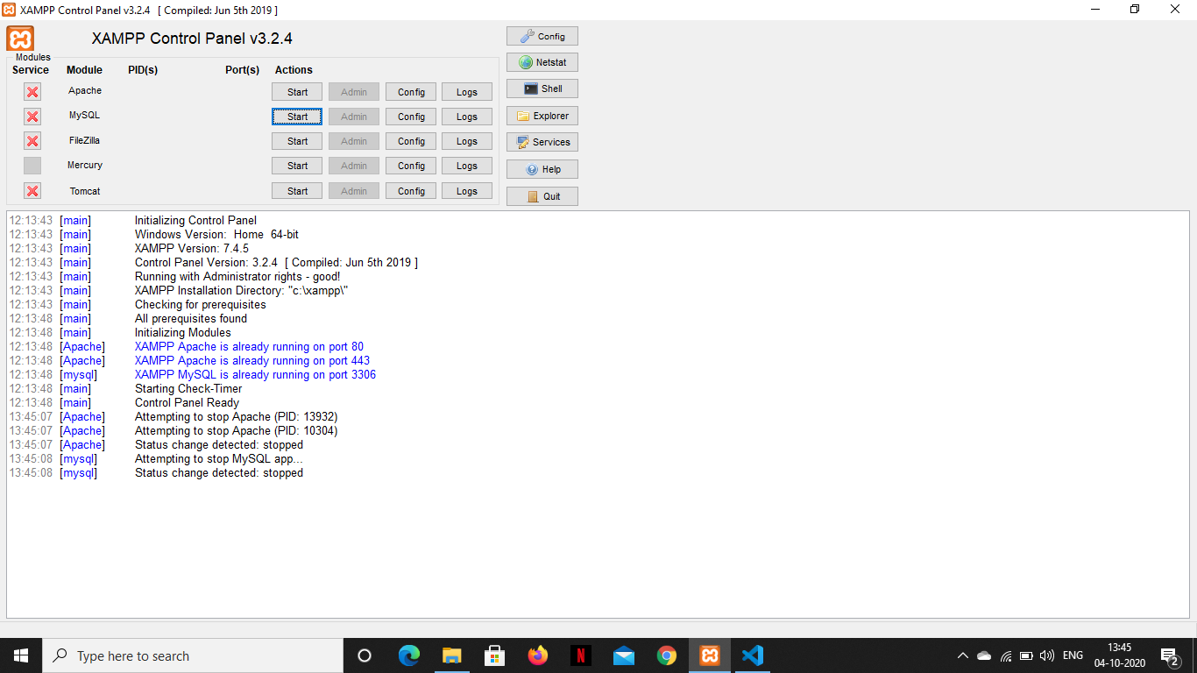

1. Click on start for apache and mysql, the server should start and should show green background for apache and mysql

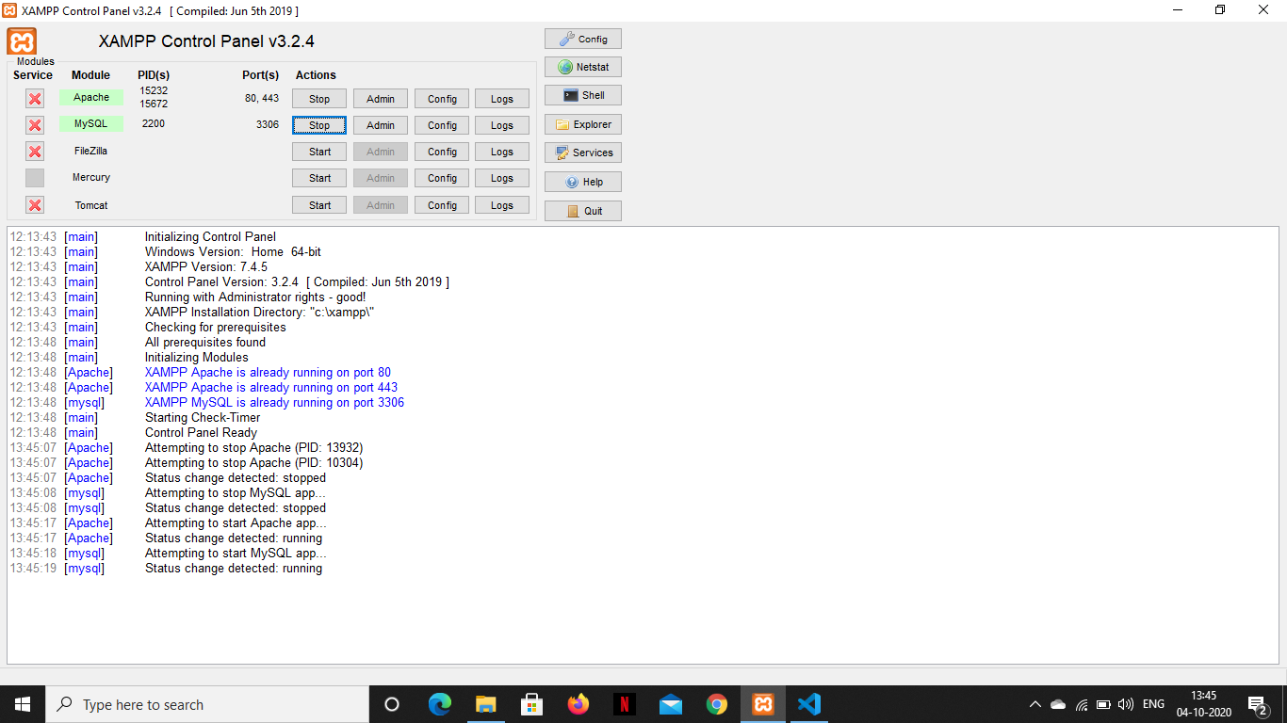

If there is any error, the has been an error in configuring the server.

1. The next step is to configure the MYSQL database.
2. Open chrome and type “localhost”, this page should show up : 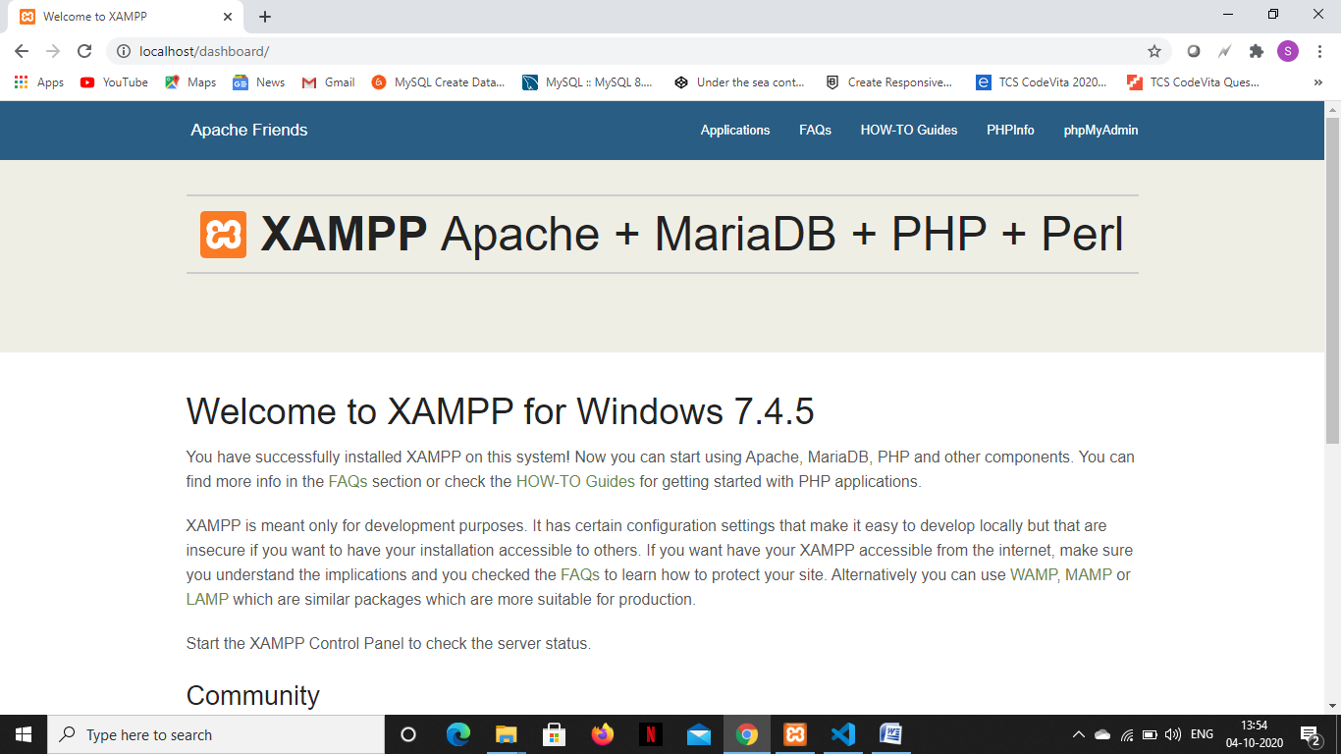
3. Click on “phpmyadmin” in the top right corner, you should be redirected to the phpmyadmin page. This page should show up : 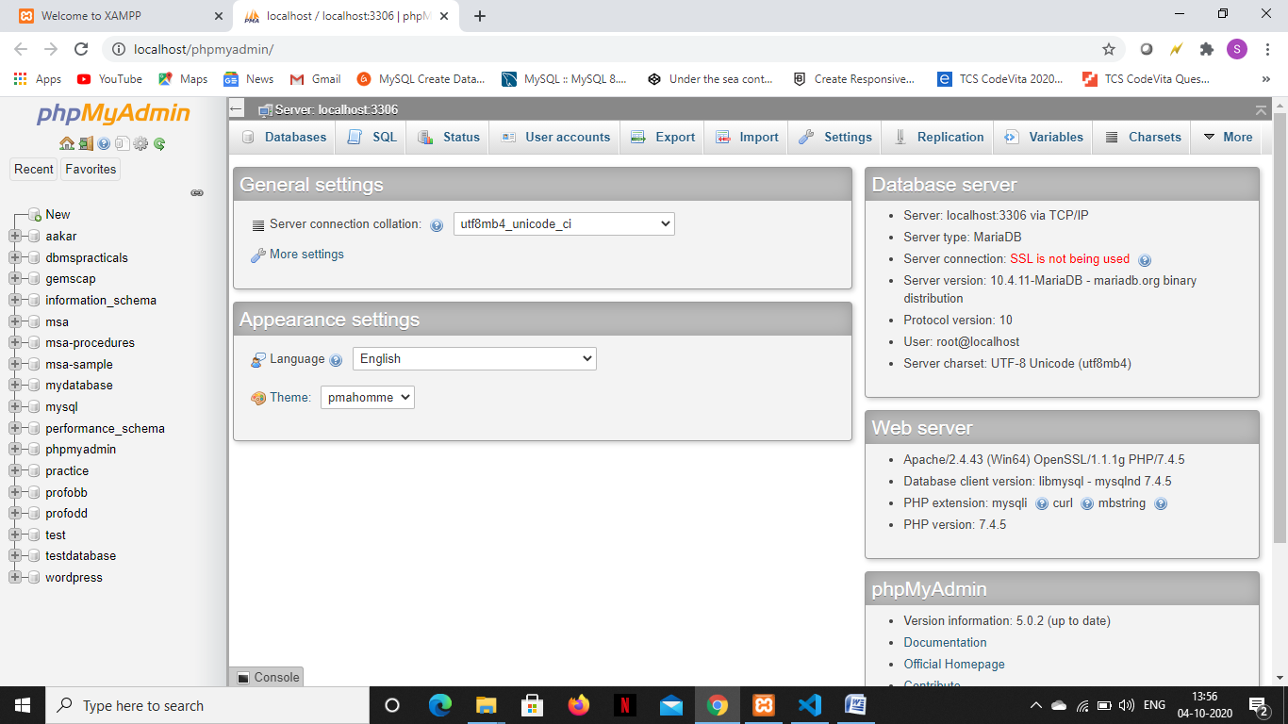
4. Click on “SQL” on the top navbar

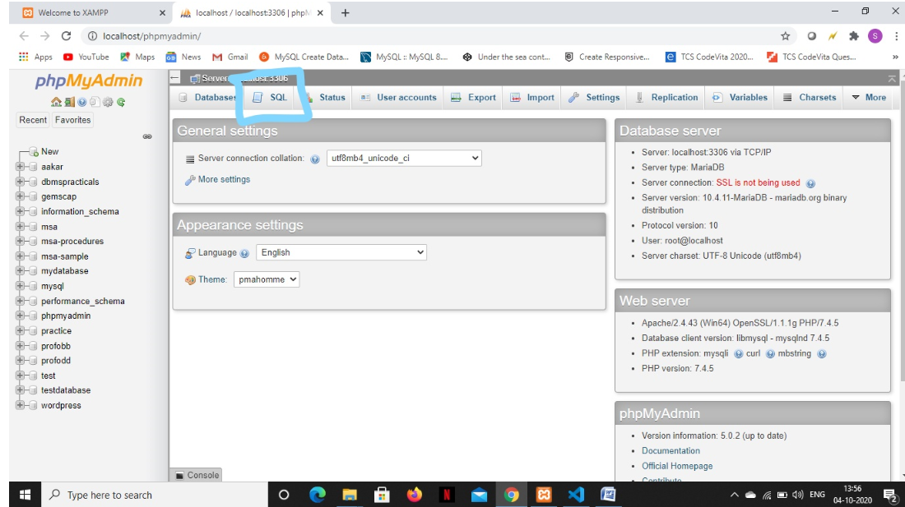

1. This page should show up : 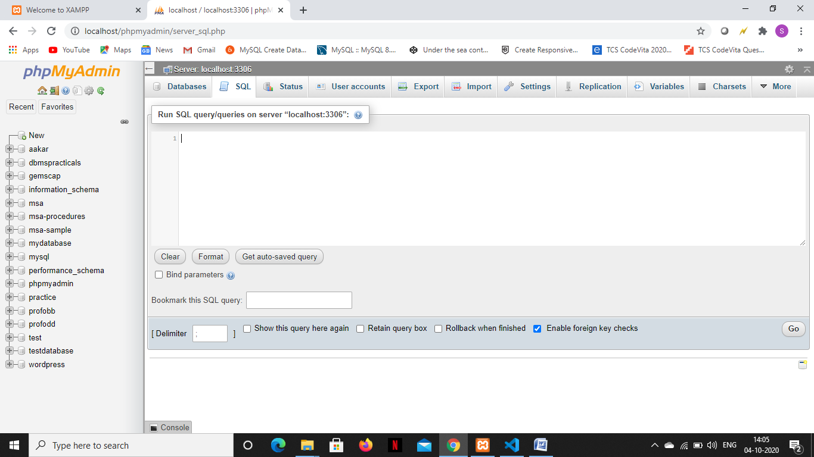
2. Now open the extracted folder and open the file “msa-sample.sql” using notepad 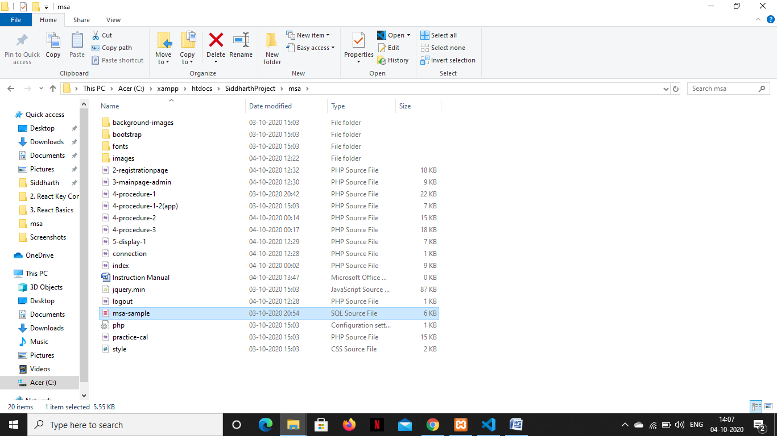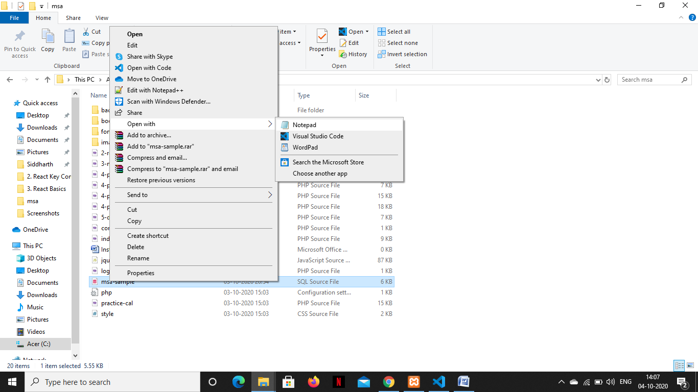

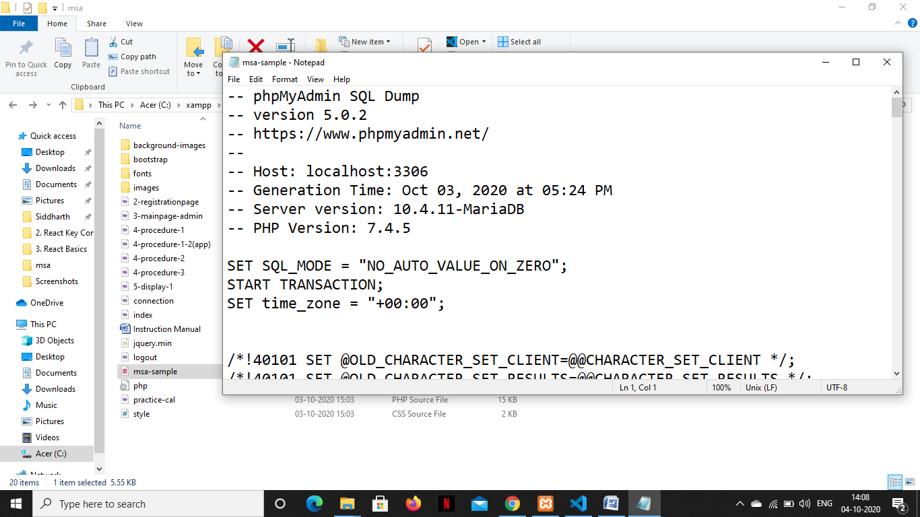

1. Copy all the contents from the file and paste it on the on the input field on the tab we opened in chrome and click on “Go” in the bottom right corner 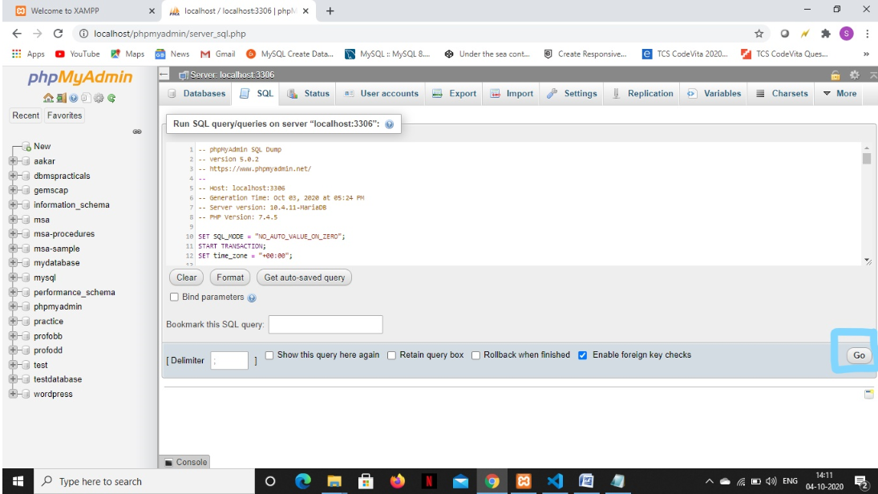
2. After waiting for a while, success messages should show up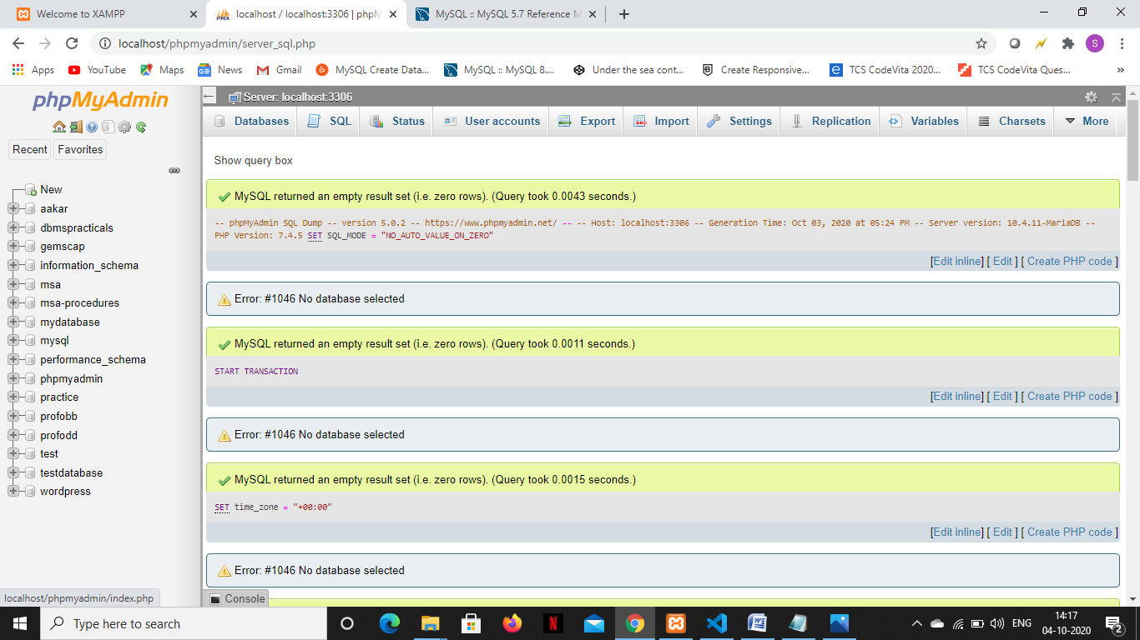and once you refresh the page, “msa-sample” database should show up on the left hand side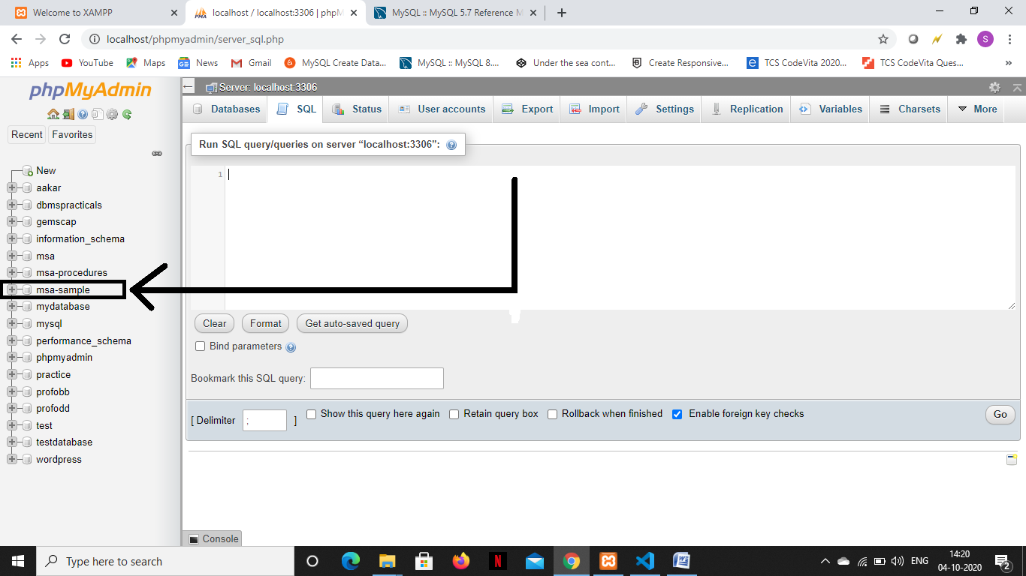You have successful configured the database.
3. Now go to the following location via your windows explorer : “C:\xampp\htdocs”, and create a new folder with any name. eg : “project”.
4. Now go inside the folder and copy and paste the extracted folder ”msa” here.
5. The application is up and running on the server. You can access it by opening chrome and going to the following url : [localhost/project/msa/](http://localhost/project/msa/). The MSA fluid interface should show up. You can login in by using a build in admin username and password. Email : [admin@gmail.com](mailto:admin@gmail.com) and password : 123. After logging in you can create your own account under “admin registration” and log in via that account further on.

NOTE : If you are conducting a procedure, make sure that you finish the procedure or it may lead to some unwanted behaviour.

Thank You,

Siddharth Kothari,

TY-IT VIIT, Pune.